TASK 2: an AWS EC2 instance manually and also provision an EC2 instance using Terraform
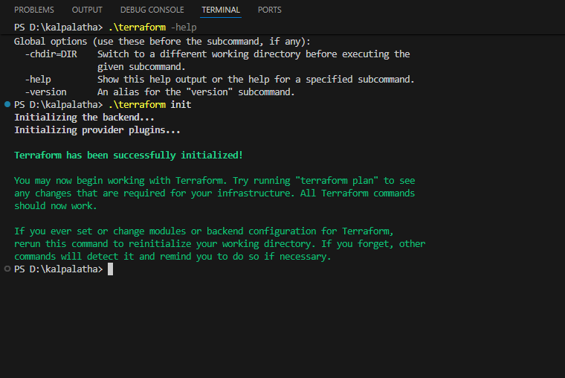
Terraform installation

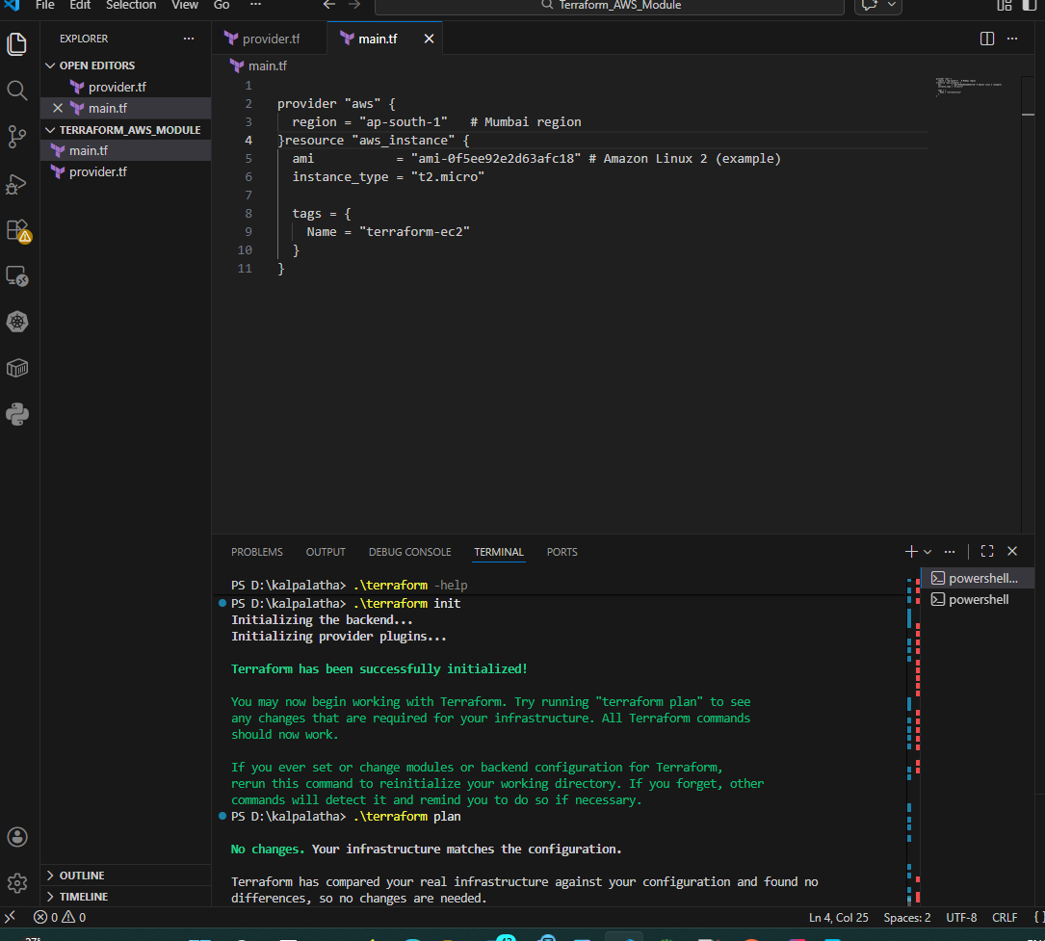

TASK 3
Terraform
├─ generates SSH key (.pem)
├─ creates AWS key pair
├─ creates security group (SSH)
└─ launches EC2 using that key
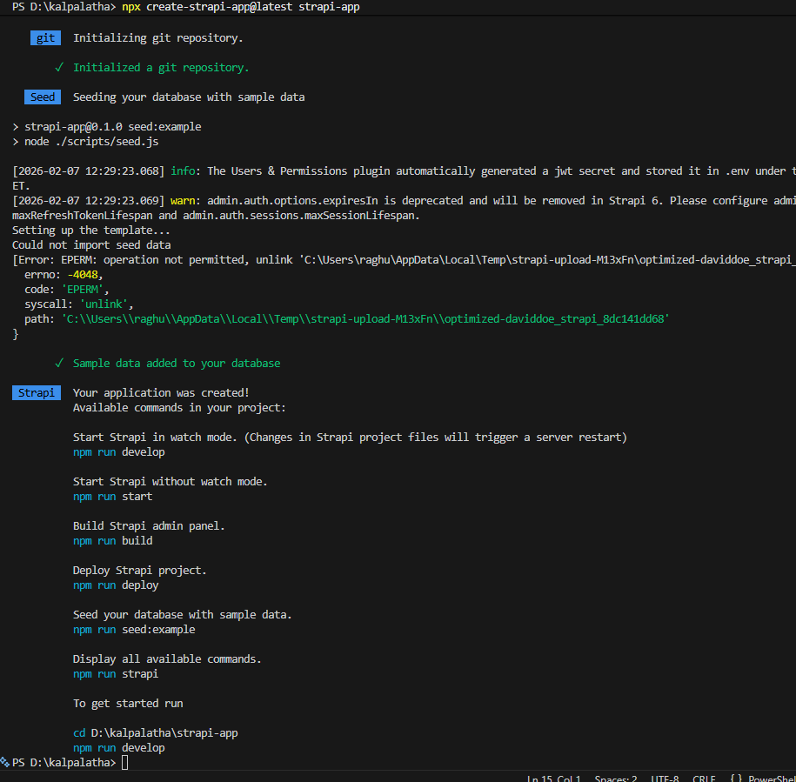
Strapi installed
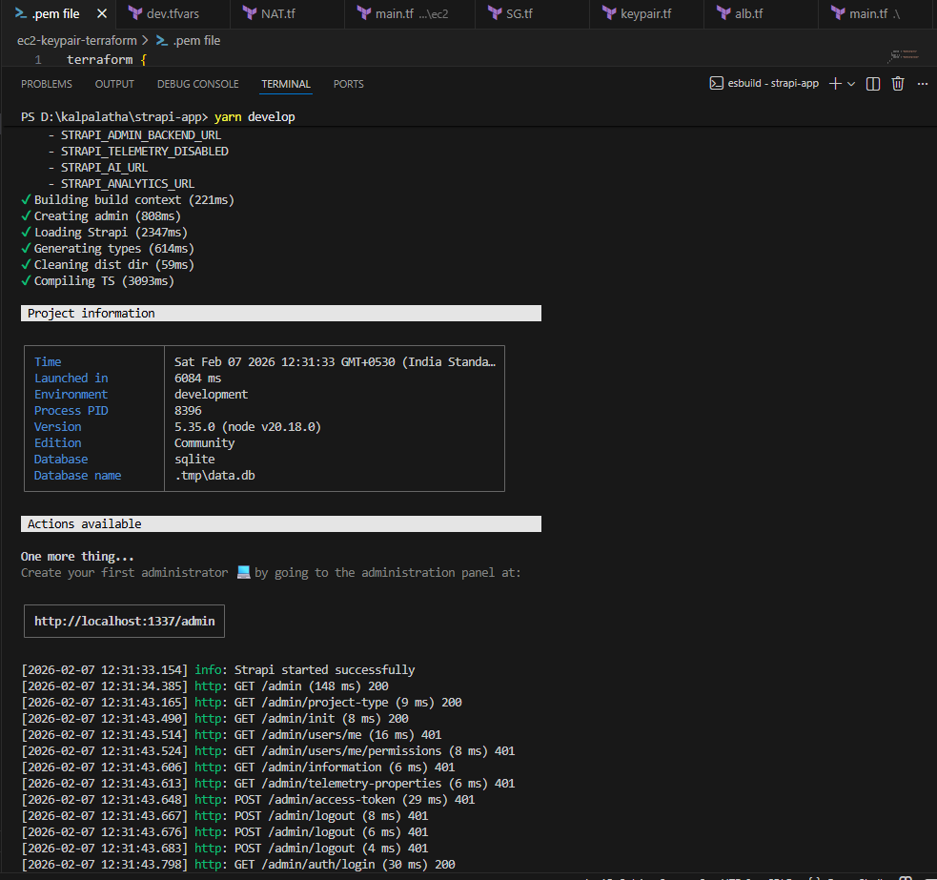

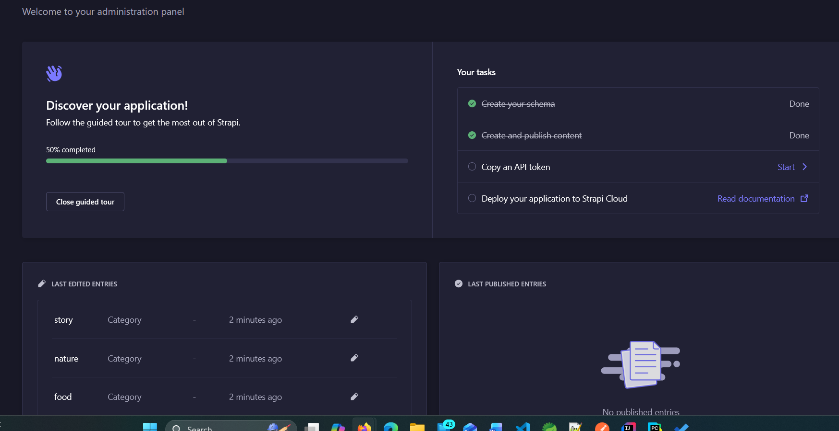
Task 4:
Aws connection through key pair to login

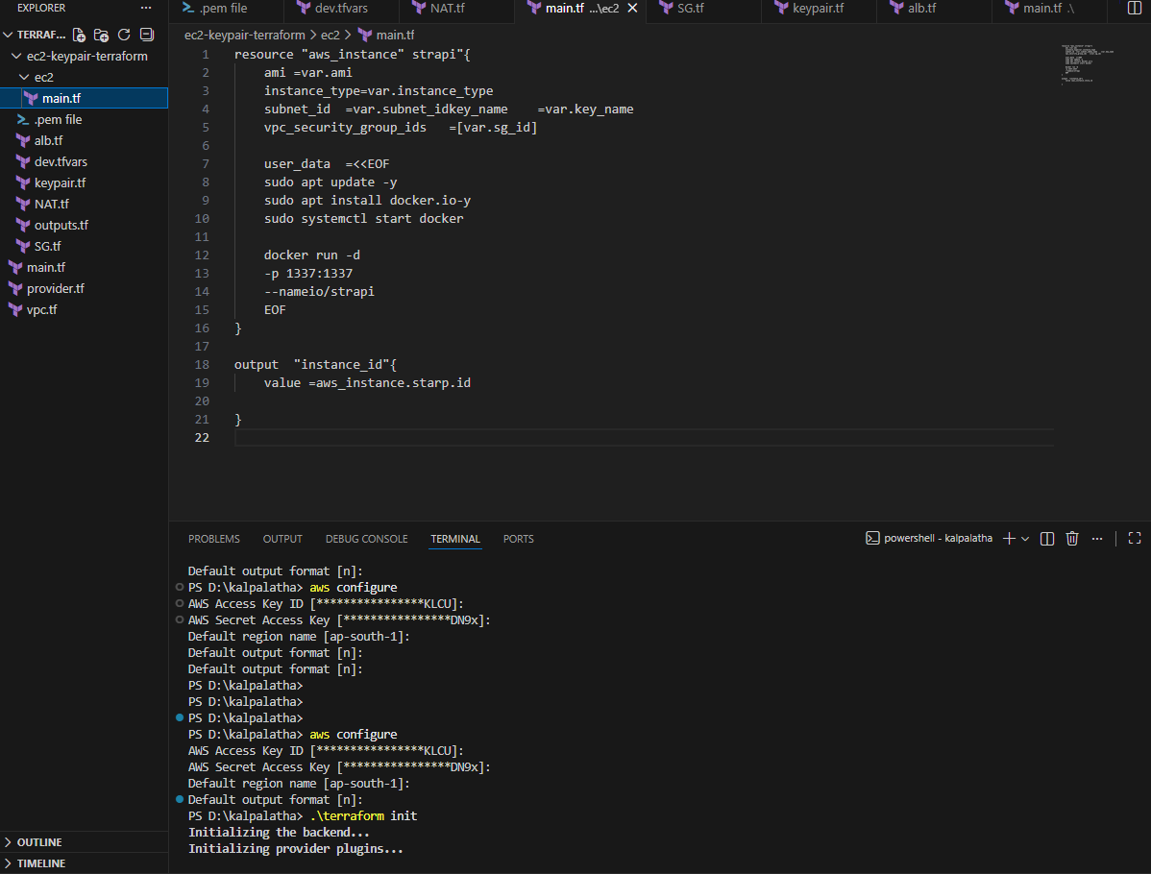
- Created vpc private and public subnets for ec2 instance and NAT Gateway for outbound internet, security g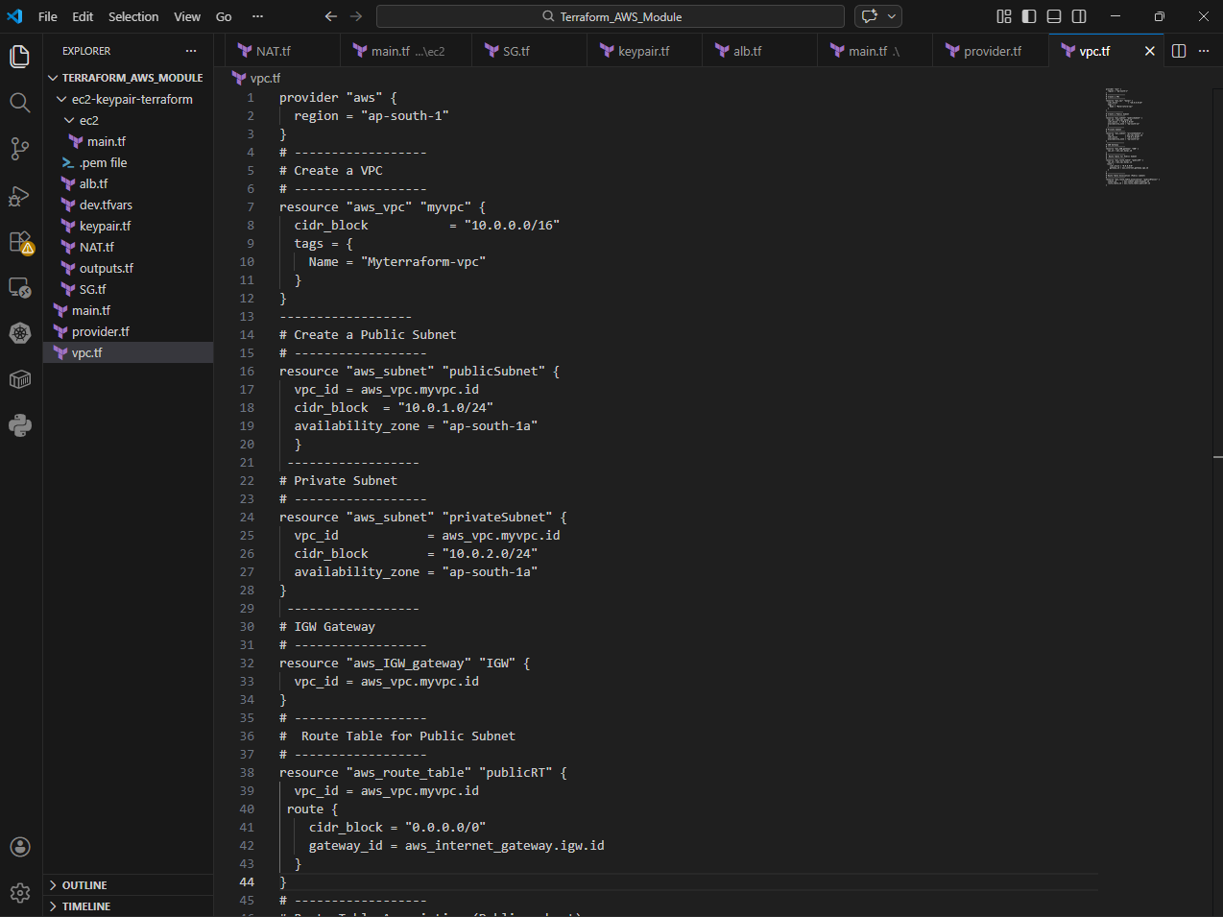roups for access control

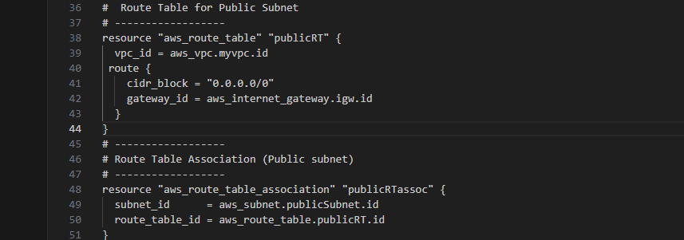
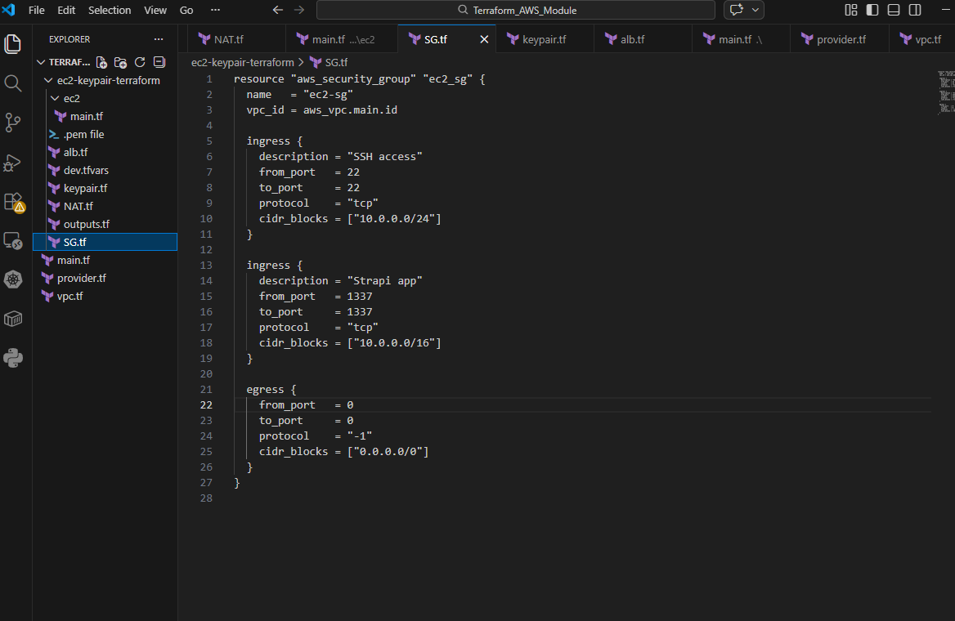

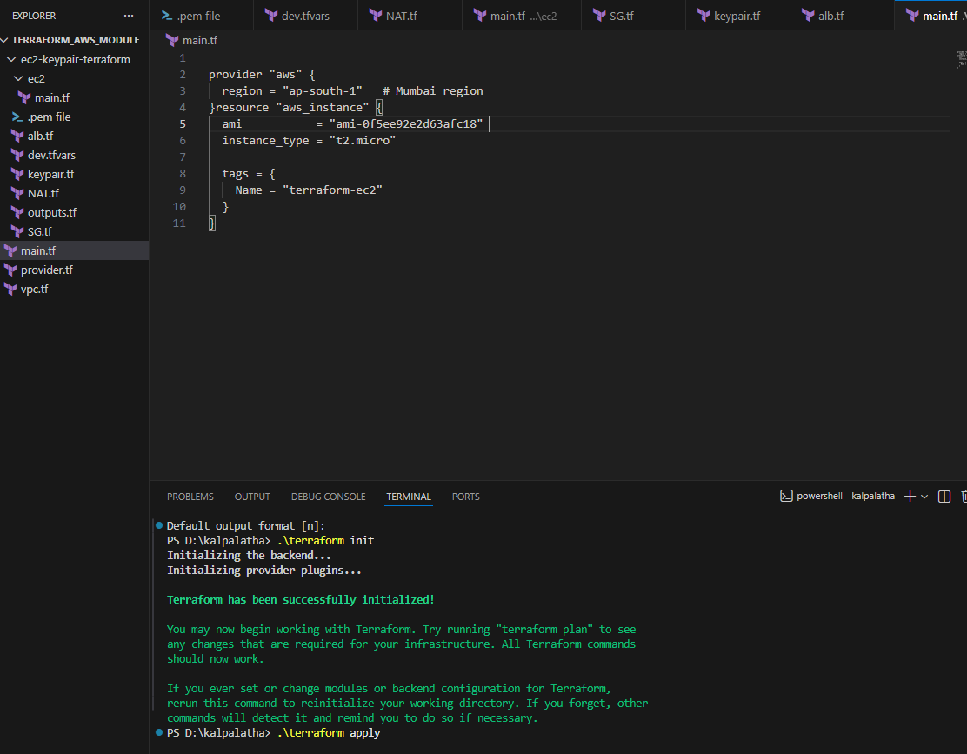

ALB
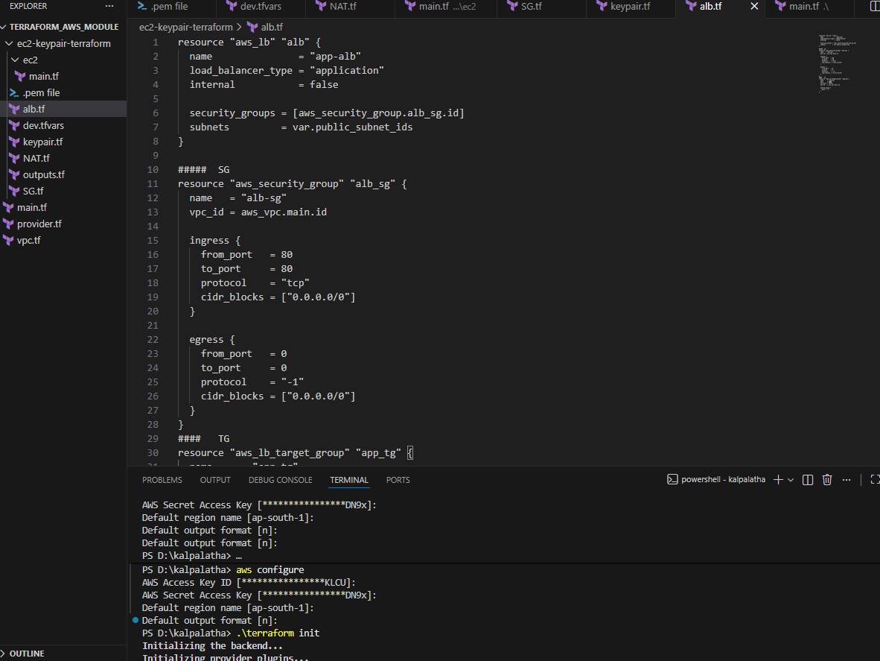

User data with docker
